Population Density - We call places densely populated if lots of people live there.
We call them sparsely populated if few people live there.
Population density map of the world

https://upload.wikimedia.org/wikipedia/commons/4/49/World_population_density_1994_-_with_equator.png

How to calculate population density. In order to calculate population density of a country, we need to do some math.

Calculating population density tells how many people live in a country compared to how big a country is in area.

Calculate the population density of Brazil
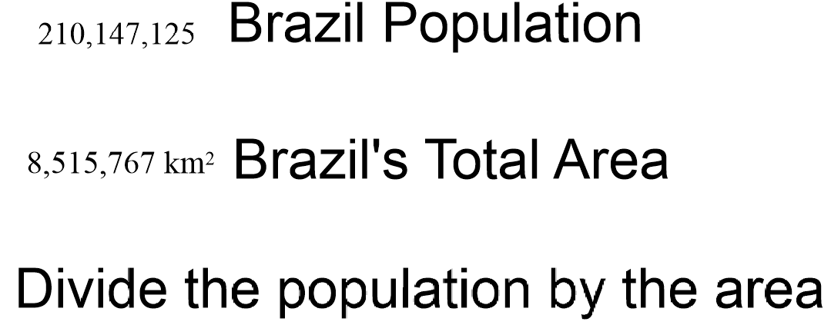

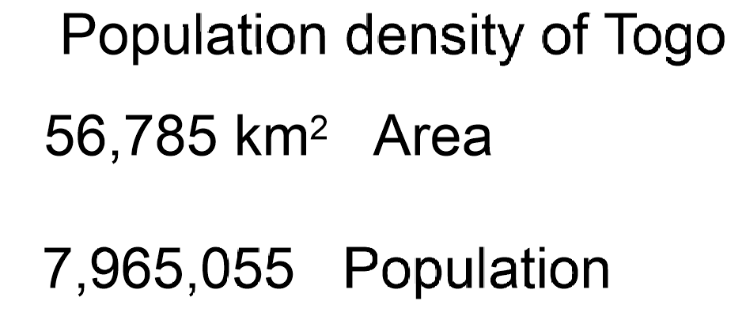

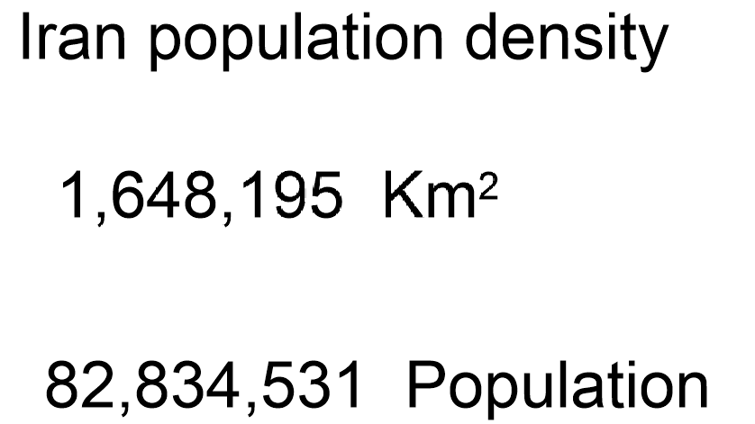

Birthrate
tells us how many babies are born per 1000 people.

Death rate tells us how many people die per 1000 people

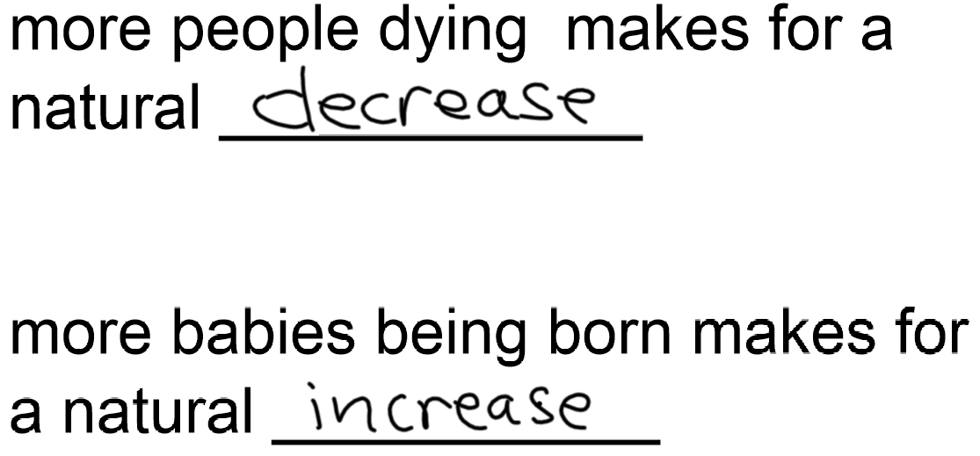

1. Show the difference between a Linear settlement a scattered settlement and a
clustered settlement using pictures and words.

When the birth rate is higher than the death rate it is called _____________.

Why would someone not want to live in a scattered settlement?

Explain what you would see or how you would know that you had entered a clustered settlement pattern.

Calculate the population
density of Austria.

Size 83 871 km2

population 8 291 743

List four factors that help to create a densely populated area.

T/F

The difference between people leaving a country and those coming into a country is called immigration.

